**Enhanced Logout Reminder Logic on Shift Change**

Taki Guan

# Version History

|  |  |  |  |
| --- | --- | --- | --- |
| Version | Author | Date | Changes |
| 1.0 | Taki Guan | 2019-4-1 | Create Document |
| 1.0 | Taki Guan | 2019-4-30 | Finish Document |
|  |  |  |  |
|  |  |  |  |
|  |  |  |  |
|  |  |  |  |

Contents

Version History 1

Purpose 1

Procedure 1

Architecture 2

Reference Link 4

# Purpose

This function is to let the log off windows don’t appear if operator login OPERA 30 min before shift change time.

This is useful for operators to avoid auto logoff screen and also keep the original design logic.

# Procedure

# Architecture

**[MES_Logon_Time]**

Create a tag name [MES_Logon_Time] in InTouch.

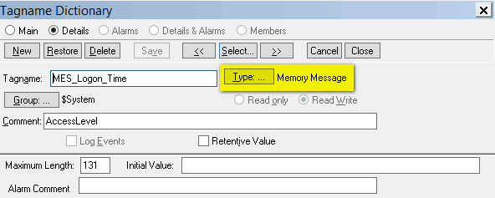

**[Script_Logon]**

Initialize [MES_Logon_Time] in [Script_Logon] script in graphic [operaGeneral_Login].

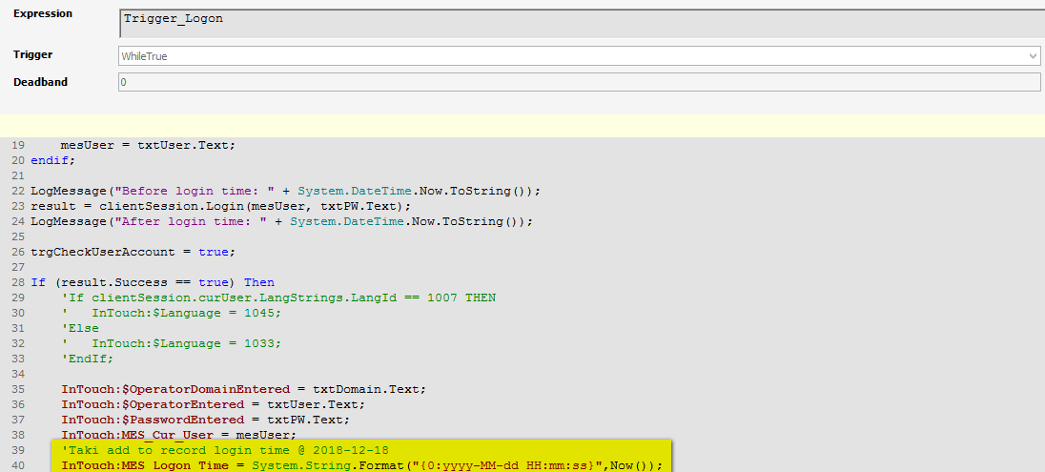

InTouch:MES_Logon_Time = System.String.Format("{0:yyyy-MM-dd HH:mm:ss}",Now());

**[opearDisplay_Status]**

Add below code in Scripts -🡪 Predefined Scripts 🡪 While True.

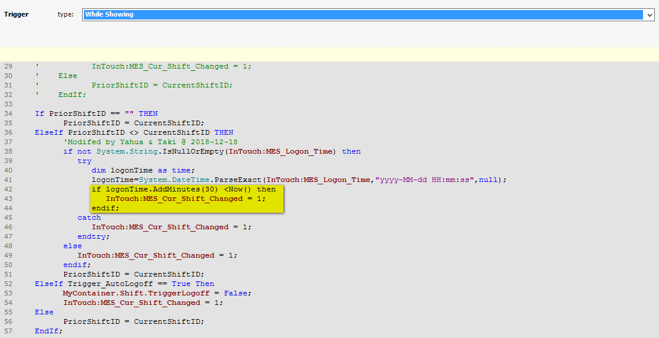

This means when user login OPERA in 30min before shift change. The Auto Logoff window will not appear.

    If PriorShiftID == "" THEN

     PriorShiftID = CurrentShiftID;

    ElseIf PriorShiftID <> CurrentShiftID THEN

*'Modifed by Yahua & Taki @ 2018-12-18*

     if not System.String.IsNullOrEmpty(InTouch:MES_Logon_Time) then

         try

             dim logonTime as time;

             logonTime=System.DateTime.ParseExact(InTouch:MES_Logon_Time,"yyyy-MM-dd HH:mm:ss",null);

             if logonTime.AddMinutes(30) <Now() then

                 InTouch:MES_Cur_Shift_Changed = 1;

             endif;

         catch

             InTouch:MES_Cur_Shift_Changed = 1;

         endtry;

     else

         InTouch:MES_Cur_Shift_Changed = 1;

     endif;

     PriorShiftID = CurrentShiftID;

    ElseIf Trigger_AutoLogoff == True Then

     MyContainer.Shift.TriggerLogoff = False;

     InTouch:MES_Cur_Shift_Changed = 1;

    Else

     PriorShiftID = CurrentShiftID;

    EndIf;

# Reference Link